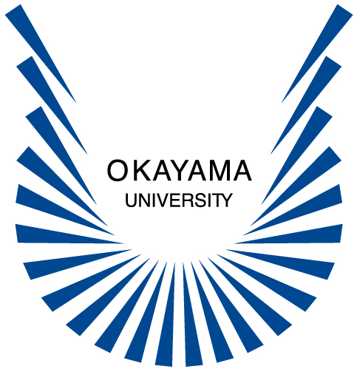
Institute of Plant Science and Resources
Okayama University
Kurashiki 710-0046 Japan
Tel +81-86-434-1244
Fax +81-86-434-1249
Contact email : kazsato@rib.okayama-u.ac.jp

July 31, 2026
Order and Assurance Form for Barley Materials

Destination:

Dear Recipient of Barley Resources,

We are required to have the Material Transfer Agreement (MTA) with all recipients of seed samples and DNA clones from our center. Before samples can be shipped from Institute of Plant Science and Resources, Okayama University, the recipient must sign a statement agreeing to adhere to the limitations on the MTA. The recipient’s retention of the material constitutes such acceptance. Please sign and return the order and assurance form to Institute of Plant Science and Resources, Okayama University, 2-20-1 Chuo, Kurashiki, 710-0046, Japan.

Thank you for your cooperation.

Sincerely yours,

Minoru Murata, Director
Institute of Plant Science and Resources
Okayama University

Institute of Plant Science and Resources
Okayama University
MATERIAL TRANSFER AGREEMENT
(MTA)

This Material Transfer Agreement sets forth the terms and conditions under which Institute of Plant Science and Resources, Okayama University (hereinafter referred to as the ’INSTITUTE’) will provide with the RECIPIENT, and the RECIPIENT will receive, the biological material specified as described in the assurance form and/or its derivatives (hereinafter referred to as the ’MATERIAL’) in response to the RECIPIENT’s request, and with which the RECIPIENT staff and organization agree before the RECIPIENT receives the MATERIAL:

The RECIPIENT shall inform the INSTITUTE for it’s written consent on the usage of the MATERIAL for any other purposes than the purpose specified in the assurance form.

The RECIPIENT agrees to expressly describe the acknowledgement of the INSTITUTE with support of National Bio-Resource Project of the MEXT, Japan as the source of the MATERIAL (example: (barley material) was provided by Institute of Plant Science and Resources, Okayama University with support in part by the National Bio-Resource Project of the MEXT, Japan) in any publication reporting the use thereof and the RECIPIENT shall send a copy of such publication to the INSTITUTE. The INSTITUTE may disclose publicly, copy or otherwise use such publication to promote the contribution by the INSTITUTE.

The RECIPIENT shall bear the cost of shipping, handling, part of production and other expenses necessary for preparation or distribution of the MATERIAL for the RECIPIENT.

The INSTITUTE agrees with the access to the MATERIAL only to those co-workers and students who work for the purpose specified in the assurance form under the direct supervision and responsibility of the RECIPIENT.

The RECIPIENT shall not distribute, resell or otherwise dispose of the MATERIAL and ITS DERIVATIVES to any third party. The disposition hereunder shall include any acts to transfer all or any part of the intellectual property or grant a license thereunder with respect to the MATERIAL.

Nothing in this AGREEMENT shall be interpreted that the INSTITUTE grants the RECIPIENT any rights under any patents or other intellectual property, or licenses thereunder with respect to the MATERIAL.

The RECIPIENT assumes all liability for claims against the RECIPIENT and the INSTITUTE by third parties relating to alleged infringement of any patent, copyright, trademark or other intellectual property rights, which may arise from the use, storage or disposal by the RECIPIENT of the MATERIAL, except for the case that the claim is caused by the gross negligence or willful misconduct of the INSTITUTE.

The RECIPIENT acknowledges that the MATERIAL delivered pursuant to this AGREEMENT may have defective, hazardous or faulty properties and may not necessarily fit for a particular purpose and that the RECIPIENT assumes all liability for any consequences resulting from the use by the RECIPIENT of the MATERIAL.

The RECIPIENT agrees that any handling or other activities undertaken in their laboratory with the MATERIAL and ITS DERIVATIVES shall be conducted in compliance with all applicable laws, regulations and guidelines. The RECIPIENT shall, if necessary, take any steps or procedures to comply with legal requirements for handling of the MATERIAL.

Both parties shall discuss to enable amicable resolution of any accidents during shipment of the MATERIAL.

Where the RECIPIENT is in breach of this AGREEMENT, the INSTITUTE may request the RECIPIENT to cease its subsequent use of the MATERIAL and other resources of the INSTITUTE.

Both parties shall discuss in good faith to enable the amicable resolution of matters, arising in connection with the interpretation or performance hereof as well as the matters which are not expressly set forth in this AGREEMENT.

Any matter or dispute, which cannot be settled through said amicable discussion, shall be subject to the exclusive jurisdiction of Tokyo District Court, Japan. This AGREEMENT shall be governed in accordance with the laws of Japan.

Order and Assurance Form

I request the following Barley Material

I accept and sign a statement agreeing to adhere to the limitations on the Institute of Plant Science and Resources, Okayama University MATERIAL TRANSFER AGREEMENT.

Accepted Research Investigator:

Signature:

Printed Name: Title:

Affiliation:

Department:

Address:

Phone:

Fax:

Email:

Purpose of the study:

Date:

******************** Please complete this form and return to ********************

Professor Kazuhiro Sato
Institute of Plant Science and Resources
Okayama University
Kurashiki 710-0046 Japan
Tel +81-86-434-1244 Fax +81-86-434-1249
email kazsato@rib.okayama-u.ac.jp

